Data Science Program

Capstone Report - Spring 2025

MediSyn: A Synergistic multi-agent AI system for IPE in medical domain

Sajan Kumar Kar,
Parv Bhargava

supervised by
Amir Jafari

Abstract
The increasing complexity of modern healthcare demands collaborative, inter-professional approaches to ensure comprehensive patient care, yet current AI solutions based on general large language models (LLMs) often fall short in delivering nuanced, profession-specific advice. This project addresses the challenge of integrating Inter-Professional Education/Practice (IPE/IPP) into an AI-driven multi-agent system designed to generate treatment plans for real-life patient cases. We demonstrate that a baseline single LLM solution performs poorly when tasked with generating treatment plans. To overcome these limitations, we propose an innovative approach that simulates real-world healthcare team interactions by incorporating a multi-agent system that dynamically creates agents based on the professions represented in each case study. Rather than relying on a hardcoded set of agents, our system extracts team member roles from real-world inter-professional case studies and assigns each agent the domain-specific knowledge and responsibilities of its corresponding profession. This approach allows, for example, a nurse agent to provide patient care insights and an oncologist agent to deliver targeted cancer treatment advice, closely mirroring real-world inter-professional collaboration. Our experiments show that this specialized, collaborative framework significantly outperforms the general-purpose LLM, paving the way for improved, context-aware treatment planning in clinical settings.

Contents
1 Introduction 4
2 Related Work 5
3 Solution and Methodology 6
3.1 Data Description 6
3.2 Data Preprocessing 9
3.2.1 Manual 10
3.2.2 LLM 10
3.3 Baseline Approach 11
3.4 Prompt Tuned LLM 12
3.5 MediSyn: Proposed Multi-Agent System 12
3.6 Evaluation Metrics 13
3.6.1 BLEU Score 13
3.6.2 ROUGE Score 13
3.6.3 LLM as a Judge 14
3.7 BRIDGE: Platform for IPE Education 15
4 Results and Discussion 15
4.1 Prompt Engineering 16
4.1.1 Structured Data Extraction Prompts 16
4.1.2 Treatment Plan Generation Prompts 19
4.1.3 MediSyn Prompts 19
4.1.4 Evaluation Prompt 20
4.2 Data Preparation Comparison - OpenAI vs Claude vs Llama 21
4.3 Treatment Plans Comparison - OpenAI vs Claude vs Llama 24
4.3.1 Manually prepared data 25
4.3.2 LLM prepared data 29
4.4 LLM vs. Prompt–Tuned LLM vs. MediSyn 31
4.4.1 Manually prepared data 31
4.4.2 LLM-prepared data 32
5 Discussion 34
6 Conclusion 35
7 References 35

Introduction

In modern healthcare, the complexity of patient needs requires collaborative approaches among diverse healthcare professionals. Interprofessional Education (IPE), as defined by the World Health Organization (WHO), occurs when “students from two or more professions learn about, from and with each other to enable effective collaboration and improve health outcomes” [1]. Building upon this educational foundation, Interprofessional Practice (IPP) involves “multiple health workers from different professional backgrounds working together with patients, families, carers, and communities to deliver the highest quality of care” [1]. These practices have been shown to enhance communication, reduce medical errors, and improve clinical effectiveness by aligning profession-specific expertise toward common goals.
With the emergence of LLMs in medical AI applications, there is growing interest in leveraging their capabilities to support or simulate such interprofessional reasoning. However, general-purpose LLMs often lack the role awareness and domain-specific context needed to replicate nuanced clinical decision-making, especially in multirole environments. These models typically produce generic treatment plans that may overlook profession-specific insights critical to comprehensive patient care.
In this work, we investigate how different LLM-based approaches perform in generating treatment plans for real-world IPE case studies. Specifically, we compare three paradigms: (1) a single general-purpose LLM, (2) a prompt-tuned LLM, and (3) MediSyn — a novel AI-driven multi-agent system that simulates an interprofessional care team by dynamically instantiating specialized agents for each role mentioned in a case. Rather than hardcoding professions, MediSyn parses the team members from the input and assigns each agent domain-specific responsibilities. For example, a nurse agent is fine-tuned to provide insights into patient care, while an oncologist agent delivers targeted cancer treatment recommendations.
Importantly, our goal is not to position MediSyn as a universally superior alternative, but rather to explore how such a system compares to more general-purpose LLM pipelines. We ask: Can simulating interprofessional dynamics through a role-specialized multi-agent framework provide advantages — or trade-offs — relative to current monolithic approaches?
Moreover, our extensive review of the current literature and AI applications in healthcare indicates that, although there are various multi-agent systems addressing tasks such as emergency response [2], interdisciplinary decision support [3], and cancer care information management [4], no existing system to our knowledge has been designed to tackle real IPE case studies using generative AI.
Through this work, we aim to provide empirical insights into the capabilities and limitations of these AI paradigms in replicating interprofessional treatment planning, and inform the design of future AI systems for interprofessional healthcare collaboration.
The remainder of this report is organized as follows: Section 2 reviews related work on AI-driven medical systems, multi-agent approaches, and LLMs in healthcare. Section 3 describes our methodology, including the dataset, preprocessing strategies, baseline generation pipelines, and the design of the MediSyn framework. Section 4 presents our experimental results comparing single LLM, prompt-tuned LLM, and multi-agent outputs across multiple evaluation metrics. Section 5 discusses key insights, limitations, and open challenges. Finally, Section 6 concludes the report and suggests directions for future work.

Related Work
The integration of large language models (LLMs) in healthcare has spurred growing interest in their use for tasks such as clinical decision support, treatment recommendation, and patient education [5–8]. While models like GPT-3 and GPT-4 have demonstrated impressive capabilities in understanding and generating medical language [9, 10], they often lack the role-specific contextual awareness necessary for profession-targeted treatment planning [11]. Their responses may be overly generic, missing the nuanced reasoning that emerges from collaborative healthcare practice involving diverse specialties.
To better address distributed reasoning, multi-agent systems (MAS) have been explored extensively in healthcare. MAS architectures simulate collaboration by assigning responsibilities to individual agents representing different medical roles [12–14]. Applications include chronic disease management, prehospital triage, cancer care coordination, and emergency response systems. These systems enable real-time communication, adaptive decision-making, and decentralized control—making them well-suited for modeling complex healthcare processes [13, 14].
The emergence of LLM-powered MAS frameworks bridges the gap between generative text reasoning and collaborative simulation. For instance, ClinicalAgent [15] demonstrates the use of GPT-4-based agents for simulating clinical trial coordination, where each agent is assigned a domain-specific function, such as patient recruitment or outcome analysis. Similarly, Han and Choi [2] developed an LLM-based multi-agent system for emergency triage using the Korean Triage and Acuity Scale (KTAS), dynamically orchestrating agents like triage nurse, physician, and coordinator for treatment planning. These systems highlight the growing feasibility of combining natural language understanding with agent-based role simulation in medicine.
Recent advancements have introduced sophisticated LLM-based multi-agent frameworks tailored for complex medical tasks. For instance, the KG4Diagnosis system integrates hierarchical agents with knowledge graphs to enhance diagnostic reasoning across various medical specialties [16]. Similarly, the MedAide framework employs specialized agents collaborating through retrieval-augmented generation to provide personalized healthcare services [17]. The MDAgents platform emphasizes adaptive collaboration among expert LLMs to tackle intricate medical decision-making processes [18]. Furthermore, the Multi-Agent Conversation (MAC) framework has demonstrated significant improvements in diagnostic accuracy by simulating collaborative discussions among agents [19]. These innovations underscore the potential of multi-agent LLM systems to replicate the collaborative dynamics of healthcare professionals, offering promising avenues for enhancing clinical decision support.
However, existing work has not yet addressed interprofessional education (IPE) or interprofessional practice (IPP) case studies using generative AI in a fully dynamic, role-adaptive way. Most prior systems rely on static agent configurations, do not reflect the diversity of real-world care teams, or are not designed for educational or collaborative training contexts [3, 11]. Our work builds upon these foundations by introducing MediSyn, an LLM-powered multi-agent system that dynamically extracts team roles from real IPE case studies and assigns them to profession-specialized agents. Rather than aiming to outperform prior methods, we explore how this novel architecture compares to single-LLM and prompt-tuned LLM baselines in generating treatment plans, particularly in scenarios requiring collaborative, role-sensitive reasoning.

Solution and Methodology
This section provides an overview of our methodology. Our approach is designed to evaluate the performance of a novel multi-agent AI system, MediSyn, for generating treatment plans in IPE healthcare scenarios. The methodology involves a structured pipeline, progressing from data extraction and preprocessing to various LLM-based generation approaches, culminating in the design and evaluation of the proposed multi-agent framework.
At a high level, our methodology can be divided into the following major components:
• Data Collection: We source our data from 18 publicly available healthcare case studies provided by the American Speech-Language-Hearing Association (ASHA). These case studies serve as authentic real-world examples of interprofessional collaboration in healthcare settings.
• Data Preprocessing: The unstructured case study narratives are processed into a structured JSON format suitable for LLM input. This involves both manual extraction and automated extraction using LLMs, allowing us to compare the effectiveness of both approaches.
• Baseline Approaches: We establish two baseline methods for treatment plan generation:
- Single LLM Pipeline — The entire case study is passed to a general-purpose LLM (like GPT-4 or Claude) to generate a treatment plan.
- Prompt-Tuned LLM Pipeline — The prompt is carefully crafted to simulate specific roles or expectations from the model.
• MediSyn: Proposed Multi-Agent System: Moving beyond single LLM baselines, we introduce MediSyn, a novel synergistic multi-agent architecture. For each case study, MediSyn dynamically identifies the healthcare team members mentioned and creates specialized agents—each representing a profession involved in the case. These agents are constrained to their domain knowledge and collaborate sequentially to generate the final treatment plan, thereby closely simulating real-world interprofessional collaboration.
• Evaluation Metrics: To rigorously evaluate and compare the outputs of the Single LLM, Prompt-Tuned LLM, and MediSyn systems, we employ both automated and human-centric evaluation methods:
- BLEU Score
- ROUGE
- LLM-as-a-Judge evaluations (for qualitative and contextual judgment)

Data Description
The dataset used in this study consists of a curated collection of real-world healthcare case studies sourced from the American Speech-Language-Hearing Association (ASHA) [20]. These case studies are publicly available on the ASHA IPE/IPP portal and are specifically designed to highlight examples of interprofessional collaboration across diverse healthcare scenarios.
Each case study presents a unique clinical situation involving patients from varying demographics and medical backgrounds, including conditions such as cleft palate, autism spectrum disorder, NICU interventions, and rehabilitation settings. Importantly, each case involves a multidisciplinary team working together to provide holistic patient care. Every case study in this dataset typically contains:
- A clinical background of the patient
- A list of healthcare team members involved (e.g., Nurse, Physician, Speech-Language Pathologist, Audiologist, Occupational Therapist)
- The collaborative assessment process and challenges faced
- The treatment plan co-developed by the team
- Patient outcomes and post-intervention progress
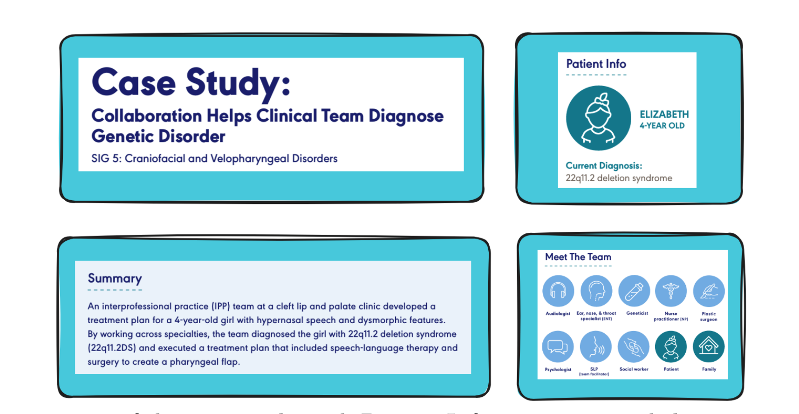
Figure 1: 1st page of the case study with Patient Info, summary, and the team members
The above diagram is a view of some of the elements in one particular case study. Each ASHA case study follows a more-or-less consistent structure comprising several distinct sections or headers, namely:
- Summary: A brief narrative of the case and its significance
- Patient Info: Demographic and clinical details about the patient
- Meet The Team: List of interprofessional healthcare team members involved
- Background: Detailed description of the patient’s history, presenting problems, and symptoms
- How They Collaborated: Narrative explanation of the collaborative process among team members
- Outcome: The outcome of the case
- Ongoing Collaboration: Whether the team is still involved in the treatment or patient care process
- History and Concerns: Often a copy of the background section
- Assessment Plan: The roles and responsibilities of each professional in evaluating the patient
- Assessment Results: Key diagnostic findings from each professional’s evaluation
- IPP Treatment Plan: The final collaboratively agreed treatment plan
- Treatment Outcomes: Follow-up details on patient progress
- Team Follow-Up: Plan for continued interprofessional communication and monitoring

To understand the features better, here’s a snapshot of the raw data:
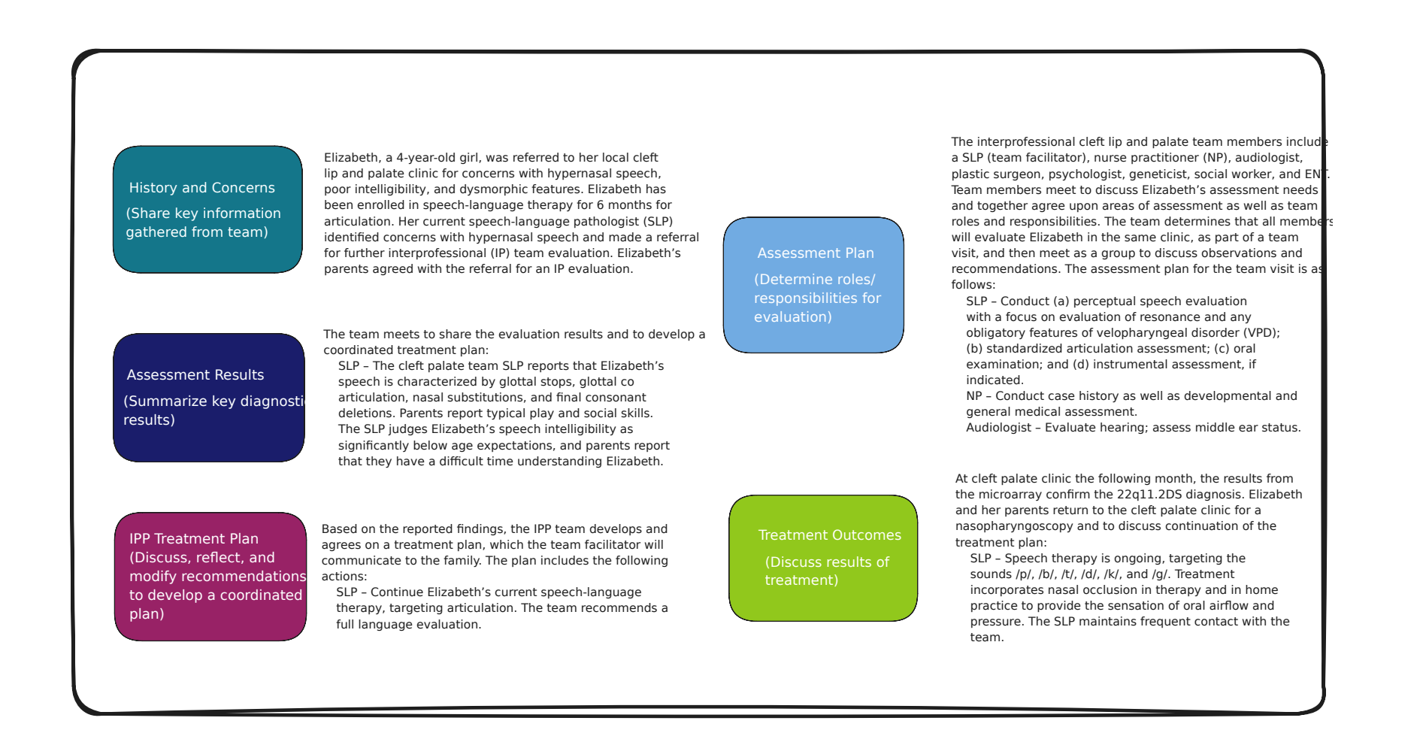
Figure 2: Data Features
In total, the dataset contains 18 such case studies. These cases serve two main purposes in our research:
- As input data for generating treatment plans using baseline single LLM approaches.
- As structured case scenarios for instantiating profession-specific agents within the MediSyn multi-agent framework.
Out of the 18 case studies available at the time of our work, we utilized 15 for our experiments. The remaining 3 were excluded from analysis due to missing a documented Interprofessional Practice (IPP) treatment plan and other critical components necessary for evaluation and generation. This dataset is particularly well-suited for simulating IPE scenarios as it authentically captures real-world interprofessional teamwork, role-specific responsibilities, and collaborative decision-making—essential elements for modeling and evaluating agentic behavior in our proposed system.

Data Preprocessing
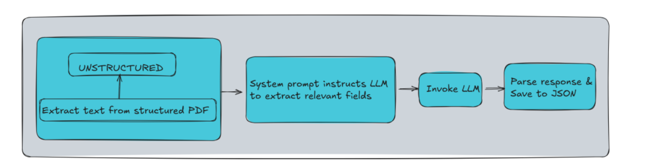
Figure 3: Data Extraction Process
Now that we have talked about the various features that a case study has. For the purpose of our work, we identified and extracted the following essential features from each case study, which directly support the downstream treatment plan generation and multi-agent modeling tasks:
Field | Description
patient_info | Includes patient's name, age, and diagnosis.
summary | Summary of the case.
team_members | List of involved professionals.
background | Patient's background.
assessment_plan | Evaluation responsibilities assigned to each professional.
assessment results | Results of diagnostic evaluations.
treatment_plan | The final Interprofessional Practice (IPP) treatment plan co-developed by the team.

The extracted information was organized into a clean JSON structure as shown below:
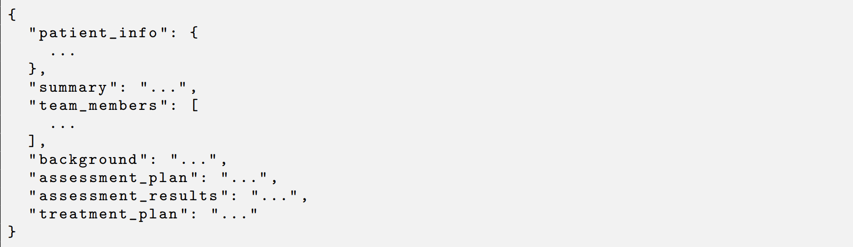
This structured representation enables a consistent input format for all subsequent methods — including baseline LLM approaches and our proposed MediSyn multi-agent system. Thing to note is the treatment plan is our target feature. To transform the ASHA case studies into the above structured format, we employed two complementary data preprocessing strategies: (1) manual extraction, and (2) automated extraction using LLMs. These pipelines enabled consistent representation of each case study while also facilitating a comparison between human- and machine-curated inputs

Manual
In the manual preprocessing approach, the data from each ASHA case study was directly extracted from the raw PDF files without any alterations or modifications. Specifically, the relevant sections corresponding to the identified features were carefully copy-pasted from the case studies and structured into JSON format as described earlier. This method ensures that the extracted data maintains maximum fidelity to the original case study content, preserving the exact phrasing, structure, and information as presented in the source. The manually curated JSON files therefore serve as the most authentic representation of the data and act as the ground truth for comparison against automated methods. This approach, while labor-intensive, was crucial in providing clean, reliable data for evaluating the performance of LLM-based extraction methods and the subsequent treatment plan generation.

LLM
In contrast to the manual extraction approach, we also explored an automated extraction pipeline using state-of-the-art Large Language Models (LLMs) to convert the ASHA case studies from raw PDFs into a structured JSON format.
We utilized three different LLMs to perform this task:
- LLaMA 3.2 70B Instruct model (accessed via AWS Bedrock)
- Claude 3.5 Sonnet (accessed via AWS Bedrock)
- GPT-4o (accessed via OpenAI API)
Each of these models was provided with the raw text extracted from the PDF files using the unstructured Python library, along with a carefully crafted prompt instructing the model to extract all relevant information and output it in the exact JSON format described earlier. The prompt structure remained largely consistent across models, with minor adjustments specific to each model’s formatting requirements. The detailed design and content of the prompt used for this extraction process is discussed in Section 4.1.
We leveraged the unstructured library to extract structured text from PDFs. A specialized system prompt was then created to instruct each model to extract the specific fields. This prompt was passed to the LLaMA 3.2 model deployed on AWS Bedrock via the Bedrock Runtime client. The generated response was parsed to extract valid JSON content, which was subsequently saved into a structured JSON file.
We repeated the same extraction process individually for all three models, thereby generating three separate sets of JSON files—one from each LLM. These generated datasets were then used with their respective models for treatment plan generation. Specifically:
- LLaMA-generated JSONs were used as input when evaluating LLaMA’s performance for treatment plan generation.
- Claude-generated JSONs were used with Claude for treatment generation.
- GPT-generated JSONs were used with GPT for treatment generation.
Further details are explained in Sections 5.2, 5.3.2, and 5.4.2.

Baseline Approach
As a foundational baseline, we first explored a straightforward single-LLM approach for treatment plan generation. In this method, a general-purpose LLM is prompted with the structured case study data—in JSON format—and tasked with generating a comprehensive treatment plan for the patient described.
This approach serves two primary purposes:
- It establishes a baseline performance level for evaluating how well a single, monolithic LLM can handle interprofessional medical reasoning.
- It allows us to contrast the effectiveness of centralized, undifferentiated AI decision-making with our proposed multi-agent collaborative system, MediSyn.
In the single-LLM setup, we use three different models for comparative analysis:
- GPT-4o (OpenAI)
- Claude 3.5 Sonnet (Anthropic via AWS Bedrock)
- LLaMA 3.2 70B Instruct (Meta via AWS Bedrock)
Each model is provided the same structured input (case study JSON), which includes key components such as patient information, background, team members, assessment plan, and assessment results. The final field—the treatment plan—is left blank and is expected to be generated by the LLM itself based on the context provided in the other fields. The specific prompts used for each LLM are documented in Section 4.1.
This single-model approach provides a valuable reference point for evaluating how general-purpose LLMs perform in the context of interprofessional treatment planning in healthcare decision-making, particularly when replicating the nuances of interprofessional collaboration. As we demonstrate in our results, while these models are capable of generating plausible treatment plans, they may lack the role-specific depth and collaborative dynamics found in interprofessional teams—which our multi-agent system is designed to simulate and explore.

Prompt Tuned LLM
To improve the performance of general-purpose LLMs without altering their architecture, we explored a prompt-tuning strategy. In this approach, we continued using the same structured case study JSON as input, but paired it with a carefully engineered system prompt designed to elicit more profession-aware, collaborative treatment plans. The goal was to simulate interprofessional reasoning within a single LLM instance, without relying on an explicit multi-agent structure. Each LLM was prompted with a specific instruction that required it to produce a treatment plan, explicitly considering the perspectives of each team member involved in the case. These prompts included role-awareness cues and formatting constraints to encourage more context-sensitive outputs. The complete prompt template used in this setting is documented in Section 4.1. The use of this structured, role-aware prompt was intended to guide the model toward producing outputs that better reflected the interprofessional dynamics and specialization seen in real healthcare settings. Importantly, while the model remained a single monolithic agent, the prompt encouraged it to emulate role segmentation and simulate internal collaboration among distinct clinical perspectives. We applied this prompt-tuned approach to all three LLMs under study—GPT-4o, Claude 3.5 Sonnet, and LLaMA 3.2—using their respective prompt syntax conventions. As detailed in Section 4, the prompt-tuned variant often improved results on both automatic and human evaluation metrics compared to the baseline LLM setup, particularly in terms of plausibility, specificity, and overall contextual relevance. However, these gains varied across models and metrics, emphasizing that prompt tuning provides a meaningful but not universally optimal enhancement.

MediSyn: Proposed Multi-Agent System
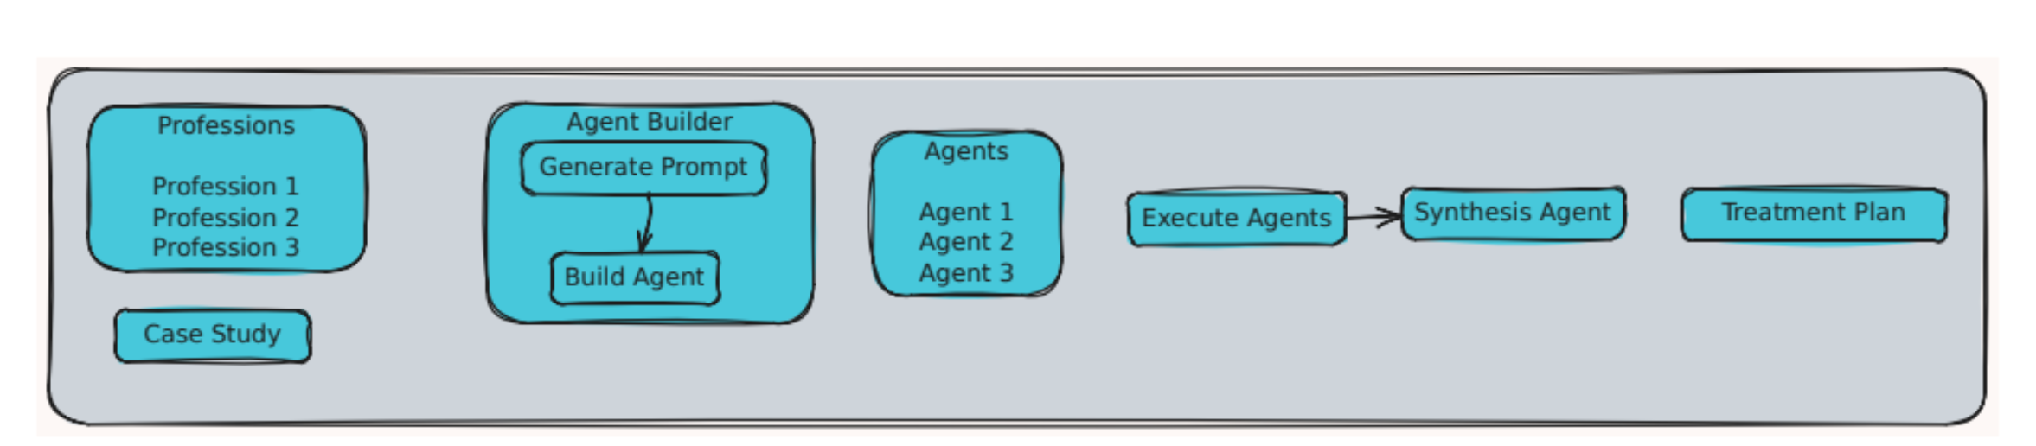
Figure 4: MediSyn Architecture
To address the limitations of monolithic and prompt-tuned LLM approaches in replicating interprofessional collaboration, we propose MediSyn, a dynamic multi-agent system (MAS) designed explicitly for IPE case studies. MediSyn simulates a virtual care team by instantiating role-specific agents aligned with the professions identified in each case study. Unlike traditional MAS architectures with static agent roles, MediSyn dynamically configures agents based on case-specific team composition, enabling flexible adaptation to diverse healthcare scenarios.
As illustrated in Figure 4, the system workflow begins with the Agent Builder, which parses the input JSON (structured from real-world IPE case studies) to extract the list of healthcare roles involved. For each role, MediSyn invokes a Prompt Generator module to construct a profession-specific prompt. These prompts encode domain knowledge, scope of practice, and context-specific responsibilities.
Next, the Agent Instantiation process launches individual agents, each constrained to reason within its domain. Each agent independently reviews the shared patient case and generates a treatment recommendation from its professional perspective. This step mirrors real-world interprofessional dynamics where specialists offer distinct but complementary contributions. Then MediSyn activates a Synthesis Agent, responsible for integrating the diverse role-specific outputs. The synthesis prompt instructs the agent to consolidate these recommendations into a coherent, role-attributed treatment plan that preserves professional distinctions. The resulting plan is presented in a standardized format with clearly labeled contributions from each team member, aligning with IPE/IPP documentation standards.
Importantly, MediSyn is model-agnostic. The system’s modular architecture allows experimentation with different LLM backends—GPT-4o, Claude 3.5, or LLaMA 3.2—at both the agent and synthesis levels. This design facilitates fine-grained benchmarking of agent-level and system-level performance across models. The system serves as both a research platform and a pedagogical tool for evaluating and enhancing AI support for interprofessional collaboration in clinical settings.

Evaluation Metrics
To rigorously compare the performance of the baseline and proposed treatment generation pipelines, we employed a blend of quantitative and qualitative evaluation strategies. Specifically, we evaluated each system—Single LLM, Prompt-Tuned LLM, and MediSyn—using two established automated metrics from the field of natural language generation (BLEU and ROUGE), as well as a qualitative assessment via an “LLM-as-a-Judge” approach (resulting to quantifiable values). This multi-faceted evaluation design allows us to triangulate both linguistic fidelity and clinical plausibility across methods.

BLEU Score
The Bilingual Evaluation Understudy (BLEU) score is a widely adopted metric for assessing the overlap between a candidate sequence and one or more reference sequences. Originally developed for machine translation, BLEU has since found utility in various generation tasks, including clinical text generation. In our setup, we compute BLEU scores to evaluate how closely the generated treatment plans match the manually extracted reference plans. We consider unigram to 4-gram overlaps to balance both local and extended phrasal fidelity. The BLEU score is formally computed as:
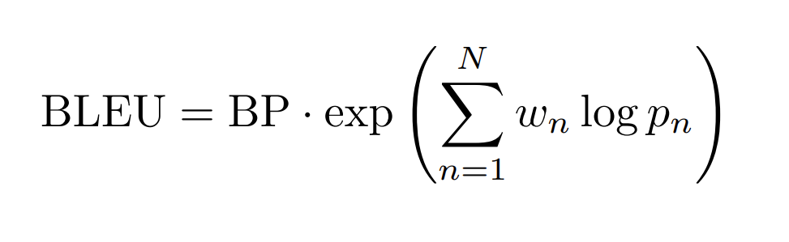
where p_{n} denotes the precision of n-grams, w_{n} are weights (commonly uniform: w_{n} = 1/N ), and BP is the brevity penalty defined as:
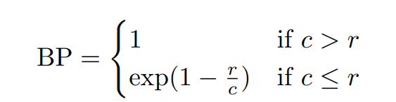
Here, c is the length of the candidate output and r is the length of the reference.

ROUGE Score
The Recall-Oriented Understudy for Gisting Evaluation (ROUGE) score is another cornerstone metric for evaluating text generation, particularly useful for summarization and structured synthesis tasks. Unlike BLEU, which emphasizes precision, ROUGE prioritizes recall, making it well-suited for capturing completeness in medical plans. We focus on ROUGE-N (with N = 1, 2) and ROUGE-L (Longest Common Subsequence) in our evaluations. The ROUGE-N score is calculated as:
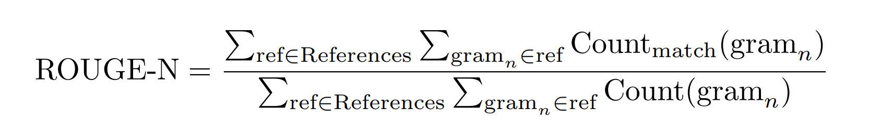
where Count_{match} refers to the number of overlapping n-grams between the candidate and reference, and Count is the total number of n-grams in the reference.

LLM as a Judge
Beyond surface-level similarity, we incorporated a qualitative evaluation framework by prompting LLMs to act as domain-aware evaluators of generated treatment plans. Specifically, we utilized GPT-4o as the evaluating model due to its strong general-purpose reasoning capabilities, fluency, and high instruction-following accuracy. These characteristics make GPT-4o particularly well-suited for evaluating nuanced clinical outputs that demand context sensitivity and professional judgment.
This evaluation strategy is inspired by recent work exploring the use of LLMs as evaluators in medical generation tasks, particularly in the context of clinical correctness and plausibility [21]. It allows us to assess the outputs across multiple clinical axes—namely plausibility, specificity, accuracy, and omission.
Each plan is blindly reviewed by an LLM, which is instructed to rate it on a 1–5 scale for each of the following criteria:
- Accuracy: Correctness and clinical relevance of recommendations.
- Plausibility: Whether the recommendations are medically sound and free from hallucinations.
- Specificity: Degree of detail provided (e.g., “hearing screening” vs. “bilateral tympanometry screening with follow-up”).
- Omission: Penalization for missing crucial clinical actions or roles.

BRIDGE: Platform for IPE Education
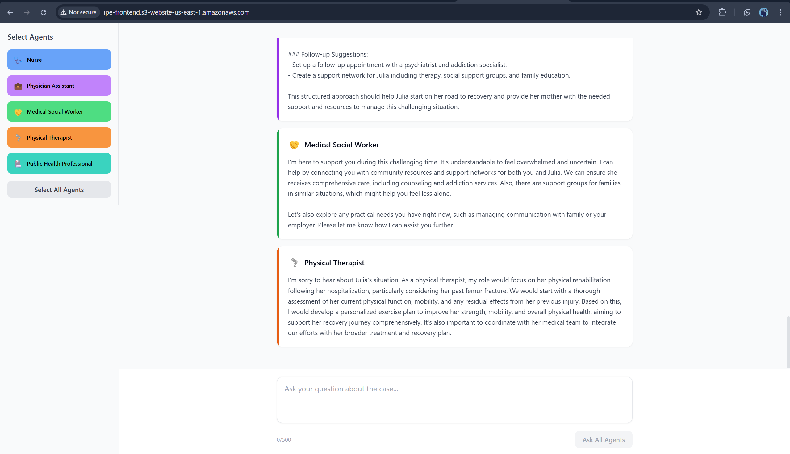
Figure 5: BRIDGE Architecture
A separate platform named "BRIDGE" was developed as a learning tool for IPE education. Bridge utilizes five pre-defined agents representing:
- Nurse
- Physician Assistant
- Medical Social Worker
- Physical Therapist
- Public Health Professional
This platform enables students to learn from interactions with these selected agents, simulating a collaborative healthcare environment.

Results and Discussion
To evaluate the effectiveness of different language model configurations in generating IPP treatment plans, we conducted a series of experiments comparing three approaches: a single general-purpose LLM (base), a prompt-tuned LLM, and our proposed MediSyn multi-agent system. The objective was to assess the degree to which each method could produce outputs that were accurate, plausible, specific to team member roles, and complete in terms of clinical content coverage.
All three methods were tested across three LLMs—GPT-4o, Claude 3.5 Sonnet, and LLaMA 3.2—under two data settings: one using case studies manually preprocessed into structured JSON, and the other using LLM-extracted structured data. We report results acrossa variety of metrics. Each method was applied consistently across all models, allowing for a controlled and comparative analysis.
Rather than seeking to identify a single best-performing system, our goal is to understand how each approach behaves under different evaluation conditions and to explore the strengths and trade-offs inherent in prompt tuning and agent-based reasoning strategies.

Prompt Engineering
Prompt engineering is the practice of designing and refining input instructions—known as prompts—to guide large language models (LLMs) toward producing desired outputs without altering their underlying parameters [22]. This technique leverages natural language cues to elicit specific behaviors from LLMs, enabling them to perform a wide range of tasks effectively. In healthcare, prompt engineering has been instrumental in various applications, such as enhancing patient–provider communication, supporting medical education, and facilitating personalized care and shared decision-making [23].
For instance, well-crafted prompts have been used to generate patient-friendly explanations of medical concepts, aiding in bridging the knowledge gap between clinicians and patients [24]. Additionally, prompt engineering has supported clinical decision-making by guiding LLMs to provide recommendations aligned with evidence-based guidelines [25]. These examples underscore the potential of prompt engineering to enhance the utility of LLMs in complex, domain-specific scenarios within the healthcare sector.
In our project, prompt engineering was integral to four key stages of the pipeline:
- Structured Data Extraction: We developed prompts that guided LLMs to parse unstructured, narrative-style case study PDFs into a structured JSON schema.
- Treatment Plan Generation: We designed prompts to instruct LLMs to produce comprehensive treatment plans by explicitly considering the perspectives of each team member involved in a case. These prompts incorporated role-awareness cues.
- Multi-Agent Role Synthesis: For our proposed MediSyn architecture, we created a specialized prompt to simulate a collaborative discussion among role-specific agents. The prompt instructed the LLM to synthesize previously generated responses from multiple agents into a single unified treatment plan, capturing key contributions while resolving redundancies or contradictions.
- LLM-as-a-Judge Evaluation: To complement quantitative metrics, we used LLMs as evaluators of treatment plan quality. A prompt was crafted to ask an LLM to assess and score treatment plans on multiple qualitative dimensions—such as plausibility, specificity, and completeness.
The complete prompt templates used in each of these stages are provided below.

Structured Data Extraction Prompts

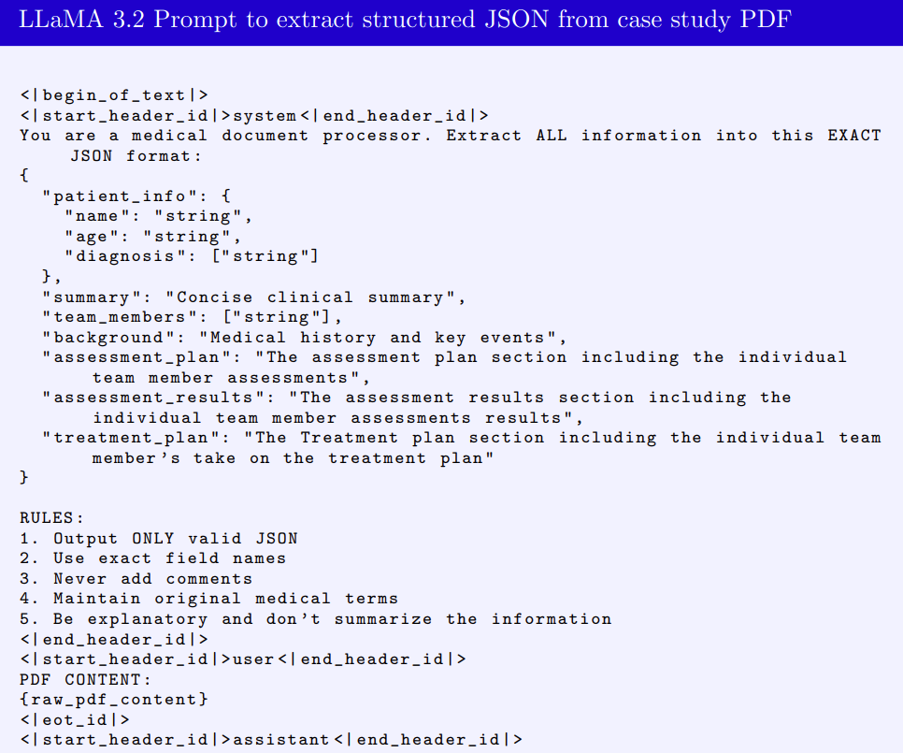
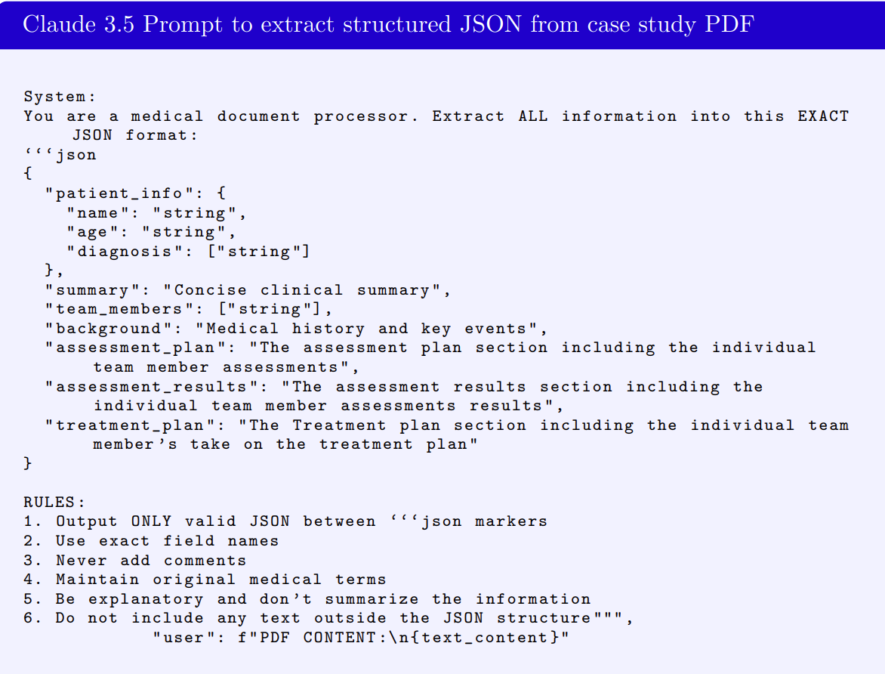
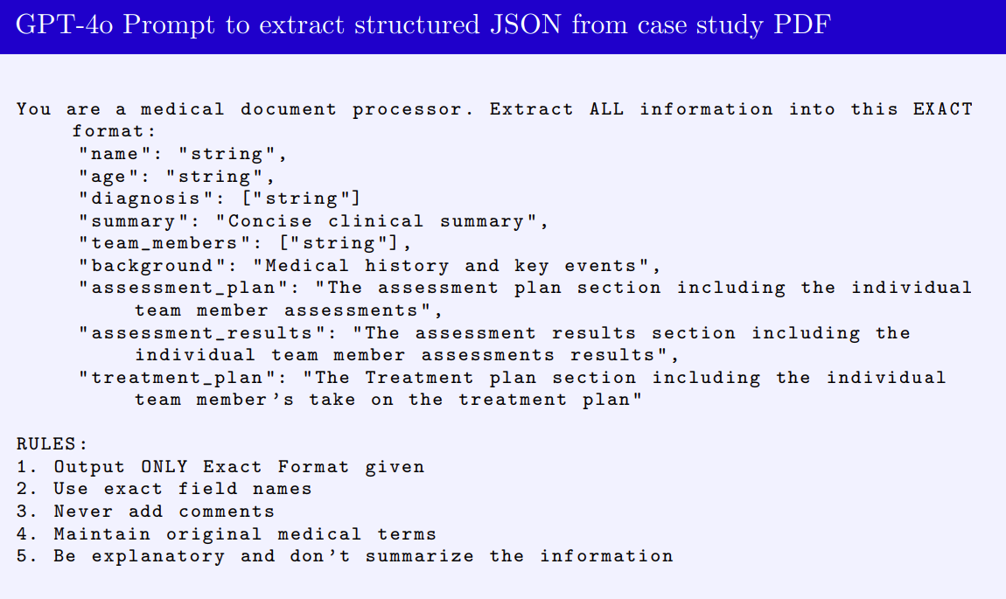

Treatment Plan Generation Prompts
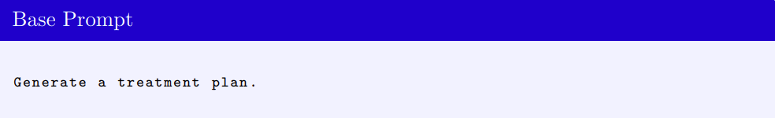
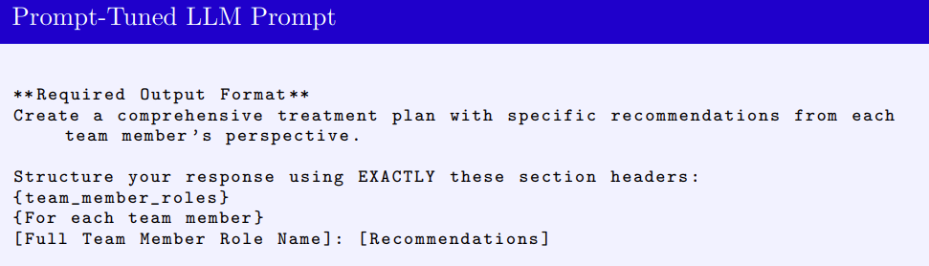

MediSyn Prompts
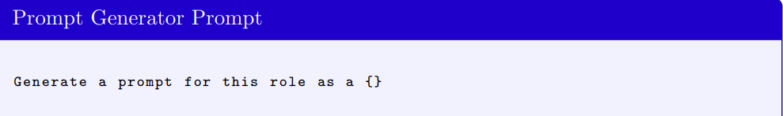
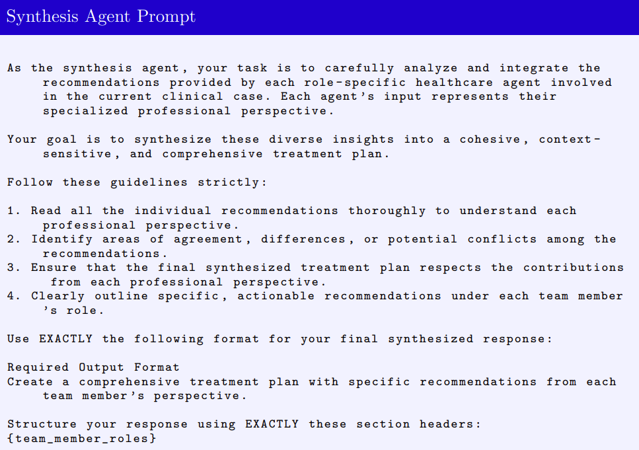

Evaluation Prompt
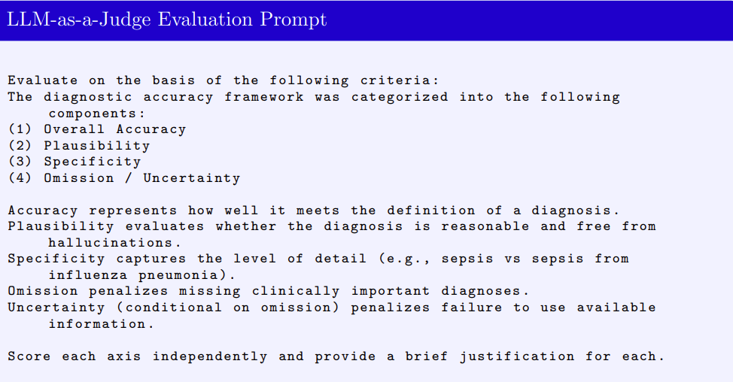
Figure 6

Data Preparation Comparison - OpenAI vs Claude vs Llama
To evaluate how well different LLMs perform at extracting structured information from unstructured medical case study PDFs, we compared outputs generated by three models—GPT-4o (OpenAI), Claude 3.5 Sonnet (Anthropic), and LLaMA 3.2 70B (Meta). Each model was tasked with converting a single narrative-style ASHA case study into a predefined JSON schema that included all relevant fields, such as patient info, summary, team members, background, assessment plan, assessment results, and treatment plan.
Outputs were qualitatively evaluated through visual inspection. Rather than assigning quantitative scores, we focused on understanding whether each model captured the essential clinical information with enough fidelity to support downstream tasks like treatment plan generation. For example, even if a model paraphrased or shortened the original text, as long as it retained the key clinical facts, we considered the output usable.
To make the differences more interpretable, we provide visual comparisons for a selected subset of fields, omitting longer fields like assessment plan and assessment results for brevity. We will walk through one representative case study to illustrate our findings, noting that similar patterns were observed across 16 the other case studies as well. For brevity, we present the comparisons for patient info, summary, and treatment plan in the main report.
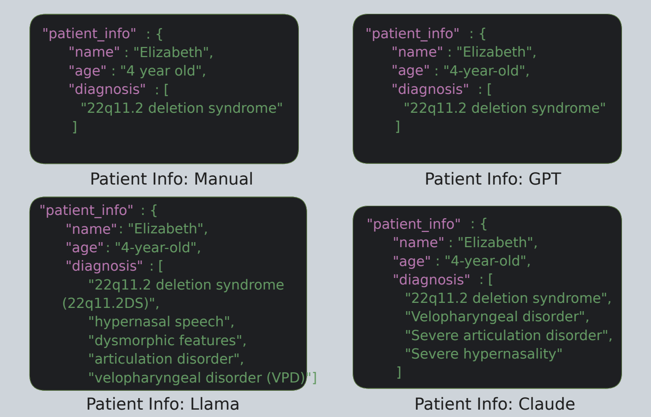
Figure 7: Comparison of patient info field

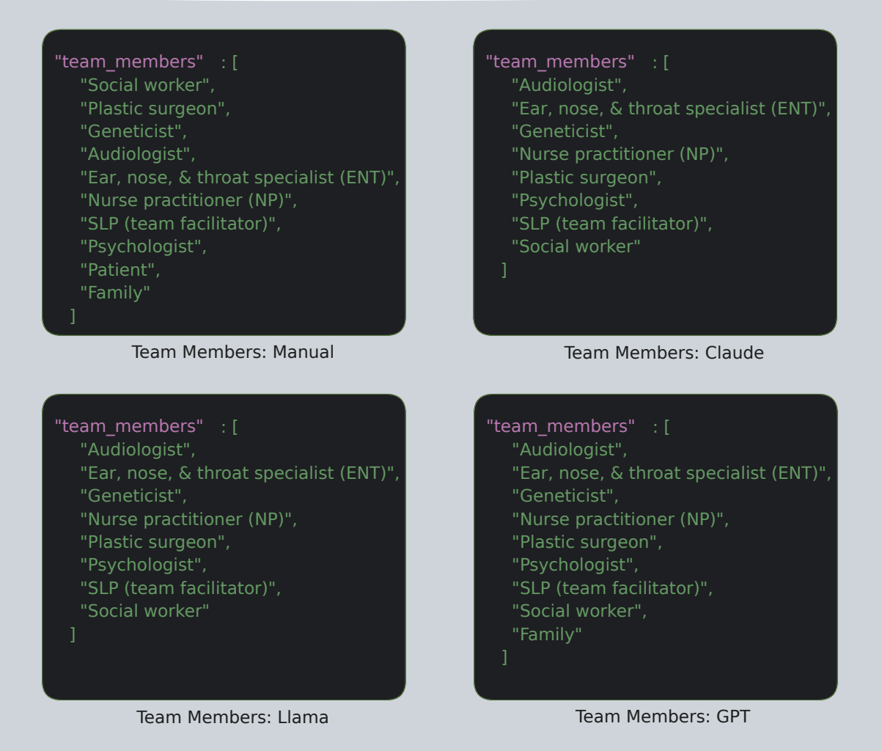
Figure 8: Team members field comparison
The patient info field contains basic demographic and diagnostic details such as the patient’s name, age, and diagnosis. All three models successfully identified and extracted the patient’s name as “Elizabeth” and represented the age as “4-yearold,” although Claude formatted it as “4 year old” (without hyphenation), and GPT preserved the format closest to the manual version.
The most noticeable difference appeared in the diagnosis field. The manually curated JSON included only one diagnosis: "22q11.2 deletion syndrome". GPT-4o reproduced this faithfully, whereas Claude and LLaMA included additional inferred conditions such as “severe hypernasality,” “velopharyngeal disorder,” and “articulation disorder.” While these additions are medically plausible and contextually relevant, they are not explicitly mentioned in the original text, making them mild hallucinations.
Overall, GPT-4o most closely matched the manual version in both structure and content. Claude and LLaMA tended to be more verbose or inferential in their outputs, which may reflect an attempt to enrich the response but could introduce unintended interpretations if used in a strictly extractive setting.
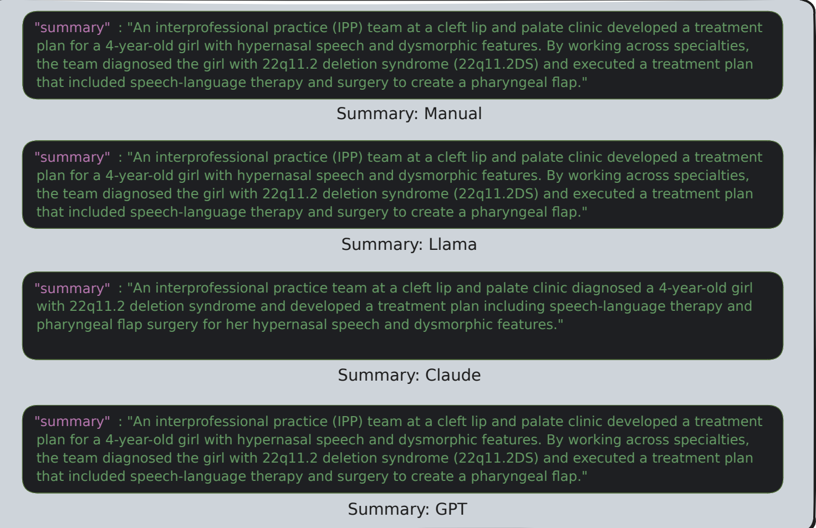
Figure 9: Comparison of summary field across manual, GPT-4o, Claude 3.5,
Both the manually extracted summary and the outputs from GPT-4o and LLaMA aligned closely in structure and wording. Claude 3.5, however, restructured the sentence slightly, opting for a more natural and narrative-driven style. It preserved the core content but combined diagnosis and planned evaluation into a smoother, paraphrased form. While the meaning remained intact, the output lacked the more factual tone and field-oriented structure seen in the manual version.
This contrast highlights a key difference in model behavior: while GPT-4o and LLaMA tend to extract text conservatively, Claude occasionally leans toward stylistic fluency, which could be beneficial for summarization tasks but may diverge from strict extraction goals.
The manually prepared version of treatment plan offers a clean breakdown with clearly delineated contributions from each role. GPT-4o generated a concise and reasonably structured plan, correctly identifying most team members and assigning plausible actions. However, its output was relatively short and omitted several role-specific recommendations found in the manual version. LLaMA and Claude 3.5 produced significantly longer and more detailed outputs. Both captured additional tasks, such as “long-term hearing monitoring” or “referrals for social support,” which were not explicitly stated in the case study but are contextually relevant. While this can add richness, it also introduces interpretive variability and potential hallucinations. Notably, both LLaMA and Claude reformatted the original structure into more prose-driven responses rather than following the explicit team-member formatting in the manual. This divergence highlights the models’ tendency to favor generative fluency over strict structural alignment when not explicitly instructed to follow a rigid schema.
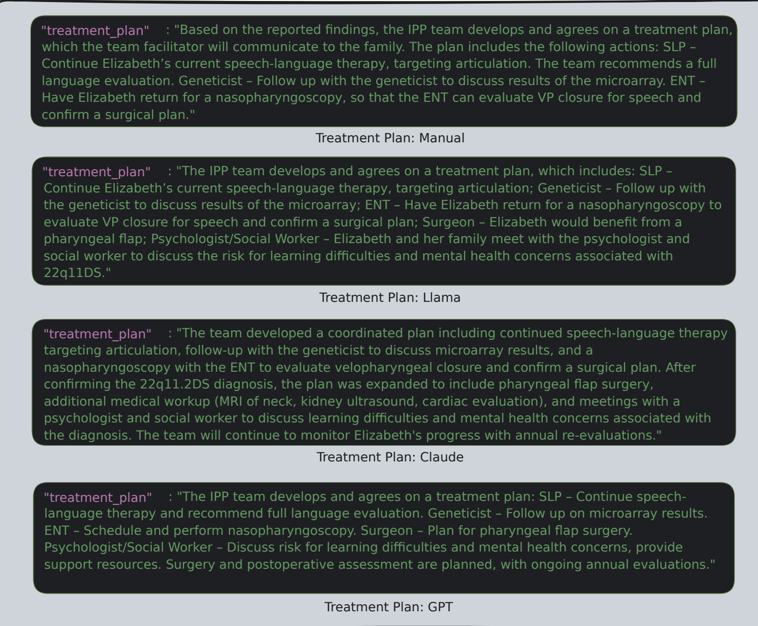
Figure 10: Comparison of treatment plan field across manual, GPT-4o, Claude 3.5,
Across the five fields examined—patient info, summary, team members, background, and treatment plan—all three LLMs demonstrated the ability to extract structured information from unstructured clinical narratives with varying levels of fidelity. Although some outputs included minor hallucinations or omitted less obvious roles, the core medical context was retained in all cases.
Ultimately, the qualitative differences observed across models were not significant enough to impact downstream performance in treatment plan generation. This supports our decision to use the LLM-specific extracted JSONs as valid input for subsequent evaluation stages, without the need for strict quantitative scoring or error correction.

Treatment Plans Comparison - OpenAI vs Claude vs Llama
In this section, we qualitatively compare the final treatment plans generated by each language model under three different configurations: base LLM, prompt-tuned LLM, and our MediSyn multi-agent system. For each of the three models—LLaMA 3.2, Claude 3.5 Sonnet, and GPT-4o—we present side-by-side outputs in image form and analyze the differences in structure, completeness, and role-specificity.
This comparison is conducted using the same case study used in Section 4.2, allowing us to directly observe how changes in prompting and agentic structure influence the final treatment plan. Our analysis is based on visual inspection of the generated texts and focuses on the qualitative aspects of interprofessional reasoning, such as clarity,LLM vs. Prompt-Tuned LLM vs. MediSyn
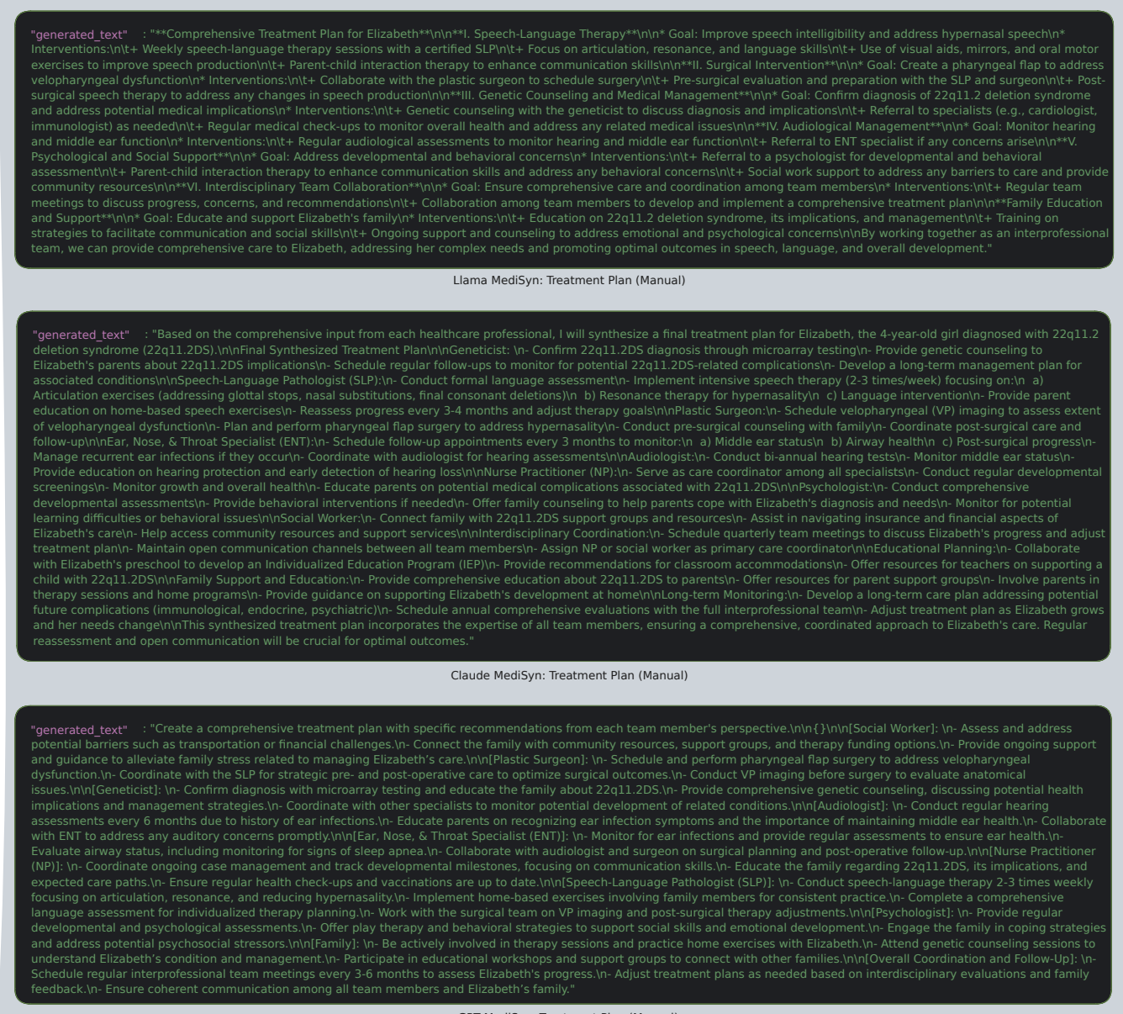
Figure 11:Combined MediSyn treatment plans generated by LLaMA 3.2, Claude 3.5,

detail, and distribution of content across roles. The goal is to assess whether the generated plans reflect the values of IPE/IPP and preserve the fidelity of domain-specific contributions.
For reference, the manually extracted treatment plan from the original case study is provided in Figure 7, as discussed in Section 4.2. This serves as a ground truth against which the generated outputs can be informally compared.
We begin with results from LLaMA 3.2, followed by Claude 3.5 Sonnet and GPT4o.

Manually prepared data
The LLama MediSyn output presents the most professional and polished plan. It organizes content into discipline-based sections (e.g., Speech-Language Therapy, Genetic Counseling) using a hierarchical structure with goals and interventions. While it does not explicitly name individual agents or team members, the sections correspond to their domains, preserving the spirit of role-aware collaboration. This structure mirrors actual clinical documentation practices and offers the best balance between readability, depth, and IPE relevance
The Claude MediSyn output closely mirrors the prompt-tuned version in content and format but appears even more cohesive. The structure is preserved nearly identically, with slight improvements in transitions and alignment across roles. This version demonstrates that Claude 3.5 handles agent-based role synthesis very effectively, integrating diverse agent outputs into a unified narrative. The result reads like a polished interprofessional plan, showing that the MediSyn architecture complements Claude’s strengths in clarity and formatting.
The MediSyn output from GPT-4o is well-structured, detailed, and clearly aligned with IPE principles. Each recommendation is grouped under team roles, and the language reflects collaborative planning and practical interventions. Compared to the prompt-tuned version, the MediSyn output appears more polished, both in tone and formatting. The addition of “Overall Coordination and Follow-Up” as a final section is a valuable touch, signaling awareness of care continuity. This output demonstrates that GPT-4o benefits from the MediSyn framework, producing one of its most comprehensive and context-sensitive plans.
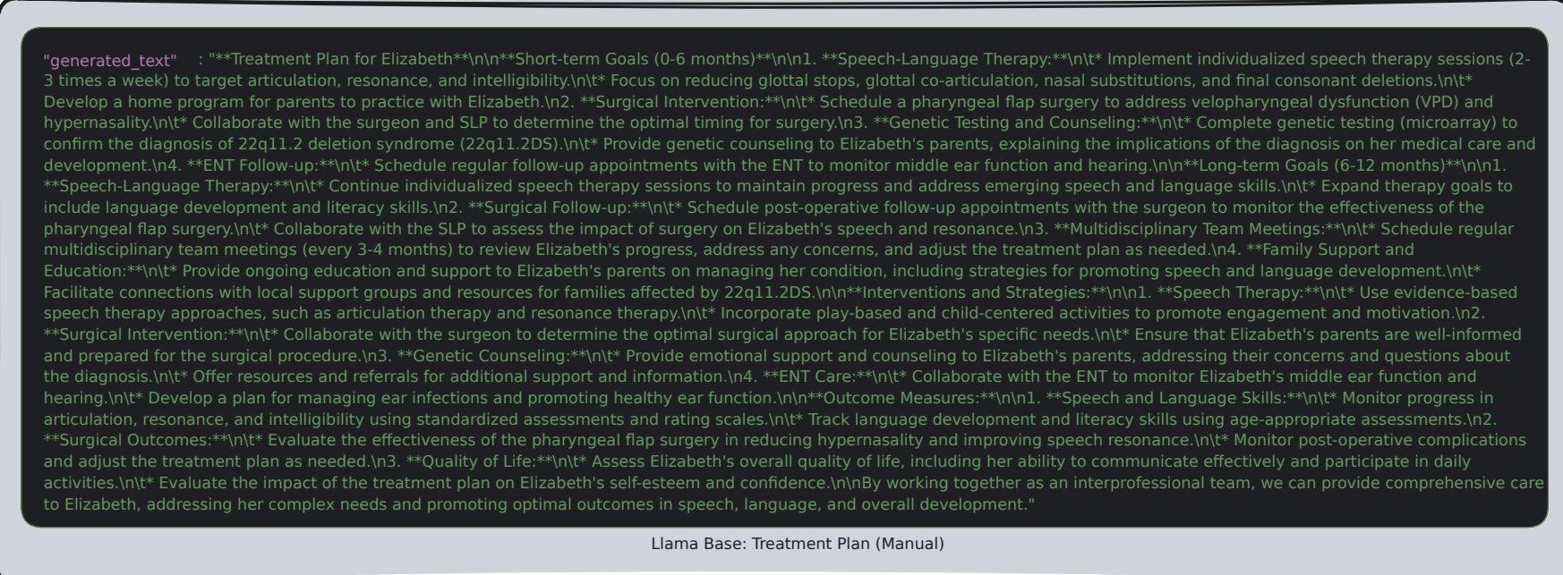
Figure 12: LLaMA 3.2
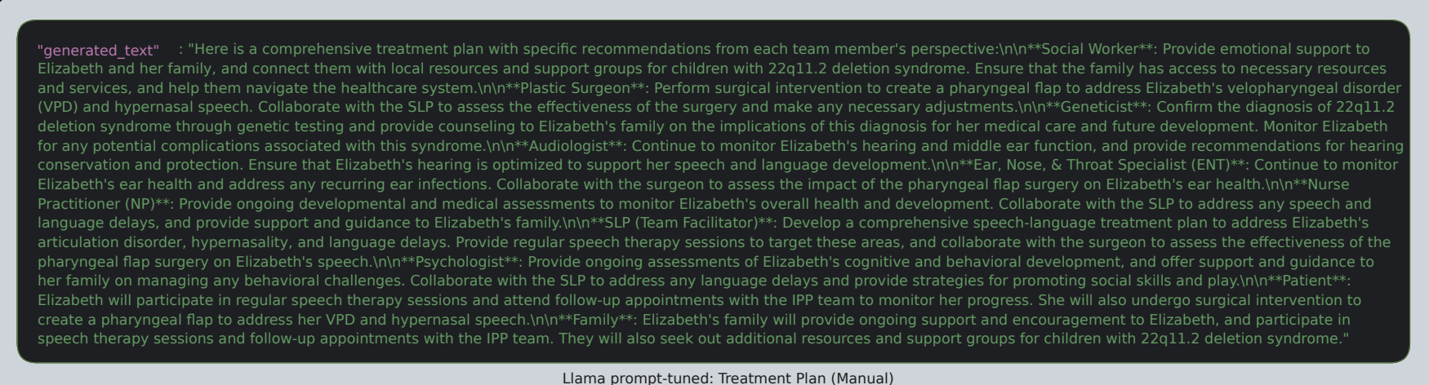
Figure 13: : LLaMA 3.2
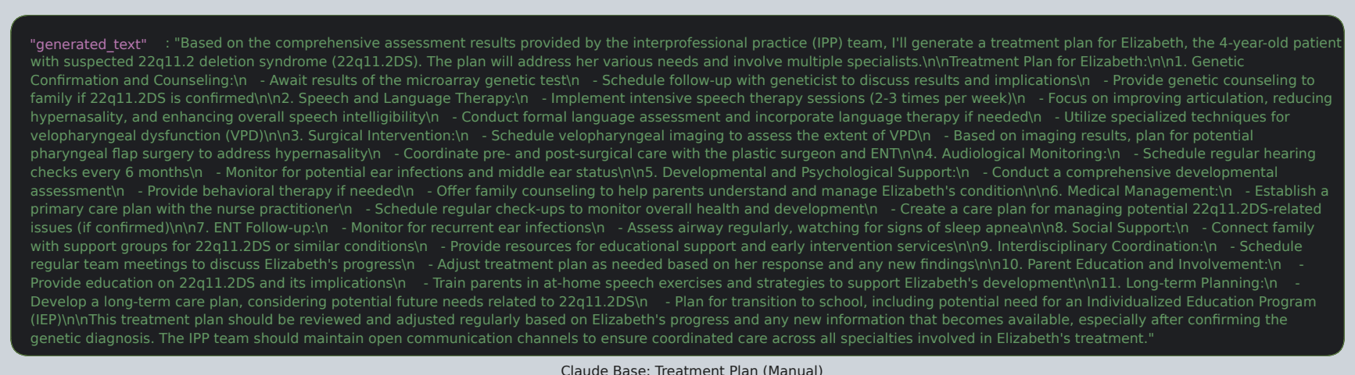
Figure 14: Claude 3.5,
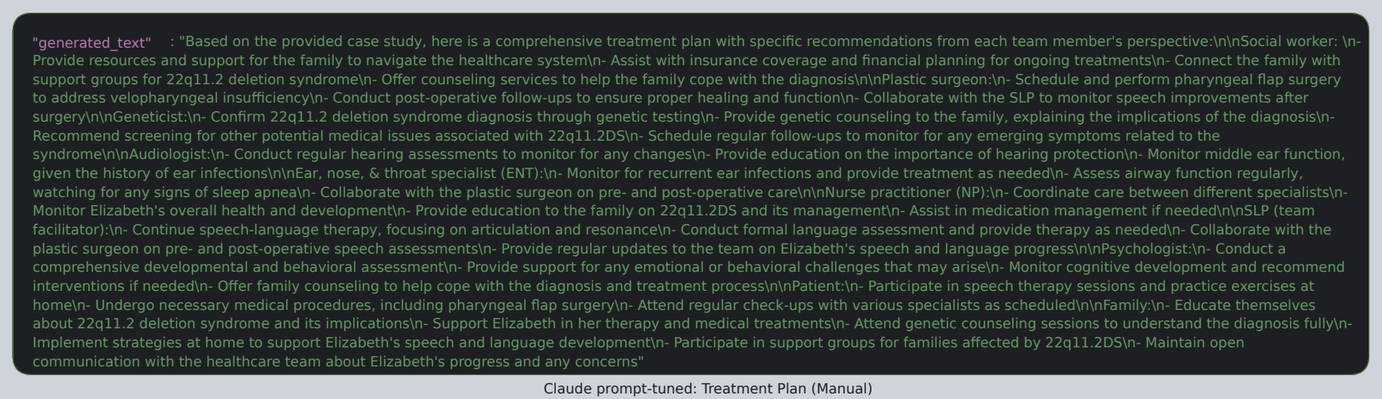
Figure 15: Claude 3.5
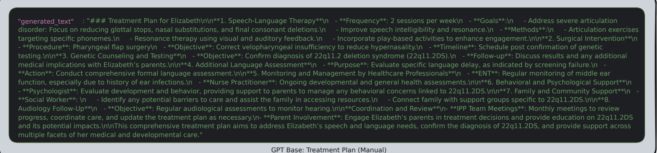
Figure 16: GPT-4o
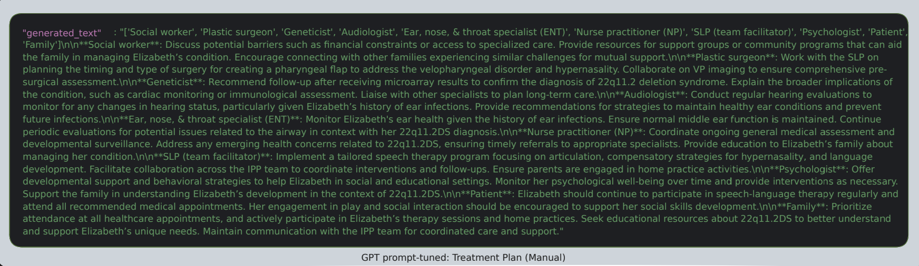
Figure 17: GPT-4o
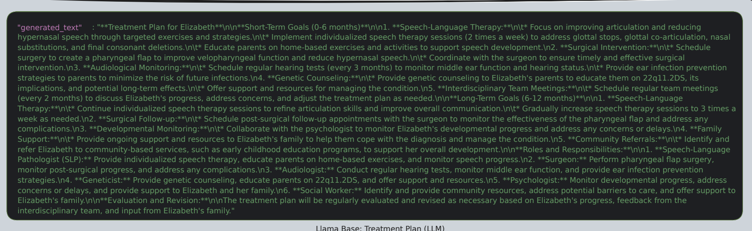
Figure 18: LLaMA 3.2:
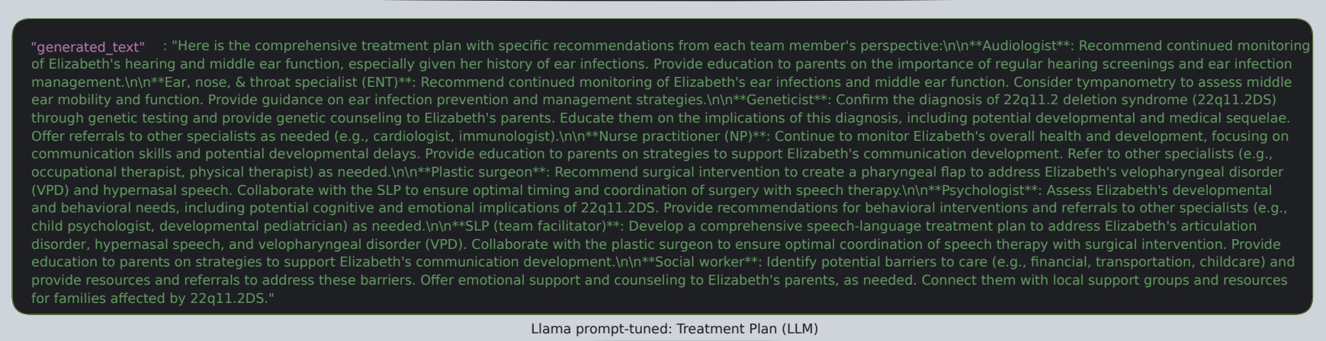
Figure 19: LLaMA 3.2:
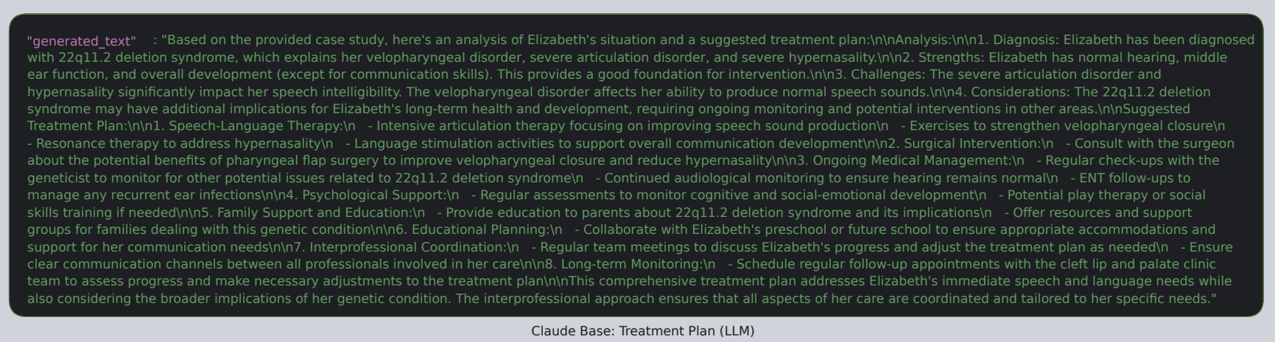
Figure 20 Claude 3.5
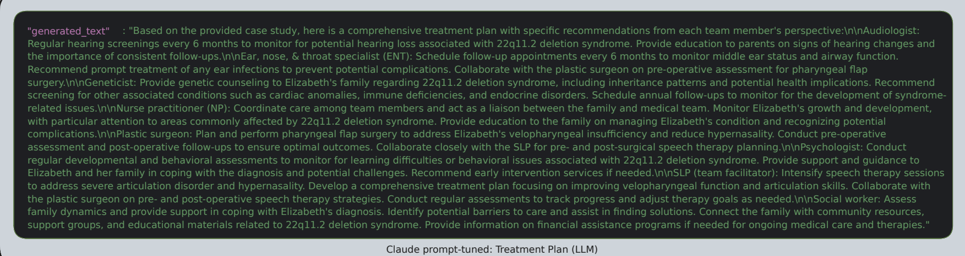
Figure 21 Claude 3.5
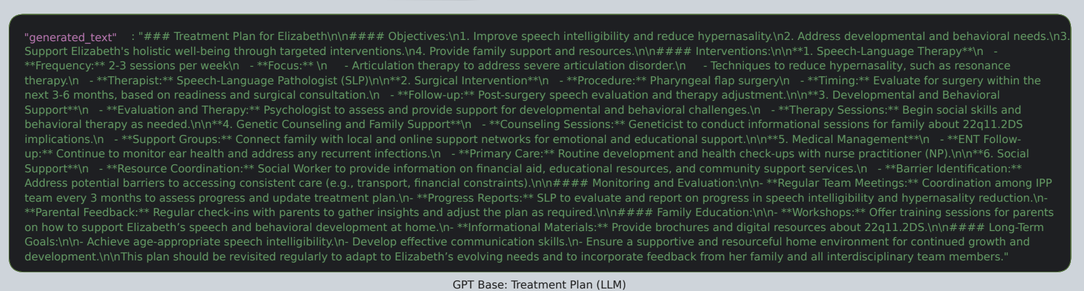
Figure 22 GPT-4o
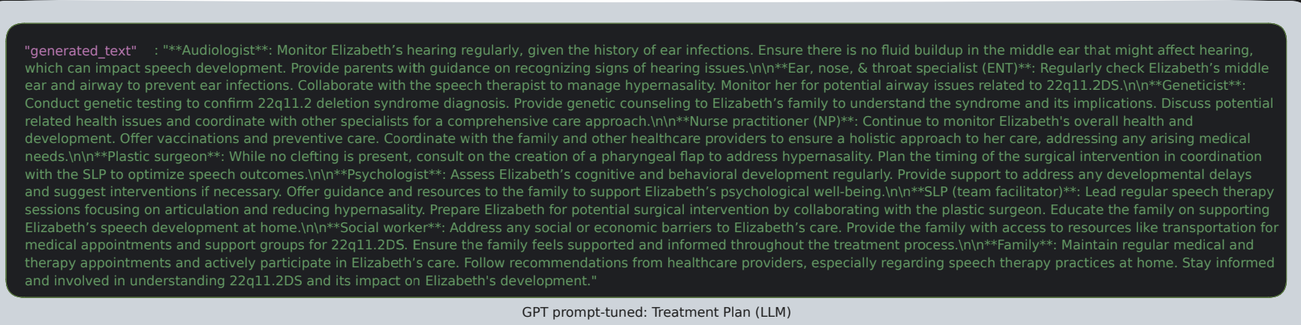
Figure 23 GPT-4o
Across all three models—LLaMA 3.2, Claude 3.5, and GPT-4o—we observed a consistent progression in treatment plan quality as we moved from the base prompt to prompt-tuned and MediSyn configurations except Llama whose prompt-tuned model gave the best results. Base model outputs, while often medically relevant, lacked consistent role attribution and structural clarity. Prompt-tuned outputs showed substantial improvement in aligning content with team member responsibilities, reinforcing interprofessional dynamics. The MediSyn outputs further refined this by synthesizing role-specific insights into highly organized and readable plans, frequently resembling real-world clinical documentation formats.
Among the models, Claude 3.5 consistently demonstrated strong formatting and fluency, especially in the prompt-tuned and MediSyn configurations. LLaMA 3.2 offered the richest medical detail, though it was sometimes lverbose or redundant. GPT-4o, while more concise, showed strong consistency in the MediSyn framework. These findings validate our system’s architectural progression and suggest that both prompt engineering and multi-agent collaboration significantly enhance treatment plan generation when from manually prepared input.
When compared to the actual treatment plan, we find that the prompt-tuned and MediSyn outputs from all models were able to preserve the essential medical context and interprofessional intent, while offering additional elaborations or reformatting for improved clarity. In some cases—particularly with Claude and LLaMA—models introduced medically plausible but inferred recommendations not present in the original, suggesting a tendency toward constructive hallucination. Overall, the MediSyn outputs most closely mirror the collaborative spirit and structural fidelity of the source plan.

LLM prepared data
We now extend our treatment plan comparison to LLM-prepared inputs, replicating the same evaluation pipeline as with manually curated data. Each model was provided with its own auto-extracted JSON (Section 3.2.2), allowing us to assess full end-toend performance. Our goal here is to understand how the quality of upstream data extraction impacts the performance of downstream generation. We again compare the base, prompt-tuned, and MediSyn configurations for each model while focusing on structure, accuracy, interprofessional clarity, and consistency with the case context.
The LLaMA MediSyn output demonstrates clear role segmentation and cohesive structure, integrating clinical and behavioral recommendations. Although some sections are verbose, the plan retains a professional tone and consistent formatting despite upstream inconsistencies, showing MediSyn’s resilience to noisy input. Compared to its manually-fed counterpart, this output performs slightly better in maintaining formatting and flow.
Claude’s MediSyn plan remains highly granular and well-organized, with clear role attributions and actionable strategies across domains such as care coordination and education. Compared to its manual-data version, Claude’s synthesis agent exhibits slightly tighter integration, likely reflecting its strength in smoothing redundancies across overlapping agent outputs.
The GPT MediSyn output again follows a team-specific structure, but with even greater interprofessional depth. It introduces less common roles such as Care Coordinator and Educational Specialist, signaling the system’s ability to reason beyond the immediate JSON input and simulate a full collaborative environment. Recommendations show better integration across roles. For example, the SLP section mentions home-based practice and resonance correction, while the ENT and Audiologist jointly focus on managing ear infections and tympanometry. The Social Worker role is also well-developed, covering transportation and financial barriers, an important IPP element often omitted in standard outputs.
Across all three generation strategies we observed distinct behavioral patterns among GPT-4o, Claude 3.5, and LLaMA 3.2 when operating on LLM-prepared data. GPT-4o consistently produced outputs that were concise, coherent, and wellstructured, particularly benefiting from prompt tuning. Its MediSyn outputs demonstrated strong role segmentation, although occasionally limited by brevity in certain roles. Claude 3.5 tended to generate highly verbose and well-articulated outputs, often including empathetic tones and explanatory elaborations. Its prompt-tuned and MediSyn plans were rich in profession-specific language, though at times overly detailed or slightly redundant. Nonetheless, Claude excelled in simulating realistic interprofessional discourse. LLaMA 3.2 showed more variability. Its base model outputs were often simplistic or overly broad, reflecting a lower capacity for nuanced interprofessional synthesis. However, prompt-tuning and MediSyn, markedly improved the result, producing detailed and diverse role-specific insights.
Overall, prompt tuning enhanced structure and specificity for all models, while MediSyn added a layer of agent-level diversity that closely mirrors the collaborative nature of IPE. While model strengths varied, the comparative analysis affirms the value of integrating both structured input and role-driven generation strategies to simulate authentic team-based medical planning.
How does the quality of treatment plan generation differ when using manually prepared data versus LLM-prepared data?
While all models demonstrated the ability to generate reasonable treatment plans in both conditions, manually curated data consistently resulted in cleaner formatting, more precise role fidelity, and lower hallucination rates. By contrast, LLM-prepared inputs introduced slight drift in structure and completeness, likely due to minor extraction errors. Nevertheless, prompt tuning and MediSyn architectures proved robust, especially for Claude and GPT-4o, maintaining high-quality team-based plans even with imperfect input. Overall, while manually prepared data offers a slight edge in quality, the LLM-extracted data pipelines remain strong and practical for end-to-end simulation.

LLM vs. Prompt–Tuned LLM vs. MediSyn
We now compare three generation paradigms—Base Agent (single LLM), Prompt–Tuned, and the Synthesis-Agent variant of MediSyn—under two input conditions: (i) JSONs obtained by manual extraction, and (ii) JSONs obtained fully automatically by each LLM. Evaluation combines surface metrics (BLEU, ROUGE-1/-2/-L) with an LLM-as-a-Judge rubric (accuracy, plausibility, specificity, omission).

Manually prepared data
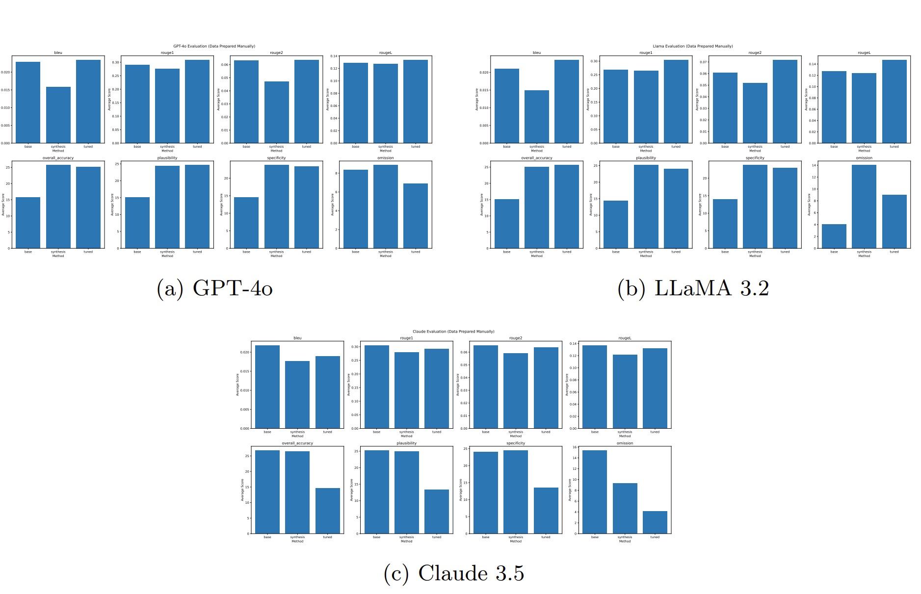
Figure 24: Metric-wise comparison across methods with manually curated data.

Across manually curated inputs, Claude 3.5 shows the strongest performance under the MediSyn configuration on human-aligned metrics such as accuracy, specificity, and plausibility. Although its base model achieves higher BLEU and ROUGE scores, these surface metrics do not reflect the interprofessional structure and role segmentation emphasized by MediSyn. For GPT-4o, prompt tuning leads across most metrics—particularly accuracy and plausibility—indicating the model’s sensitivity to direct instruction. MediSyn remains close in performance but does not significantly surpass tuning. In the case of LLaMA 3.2, prompt-tuned output achieves the highest accuracy and plausibility, while MediSyn improves specificity at the cost of slightly higher omission and reduced BLEU/ROUGE alignment. Overall, the synthesis agent boosts interprofessional fidelity but introduces moderate tradeoffs depending on model characteristics.

LLM-prepared data
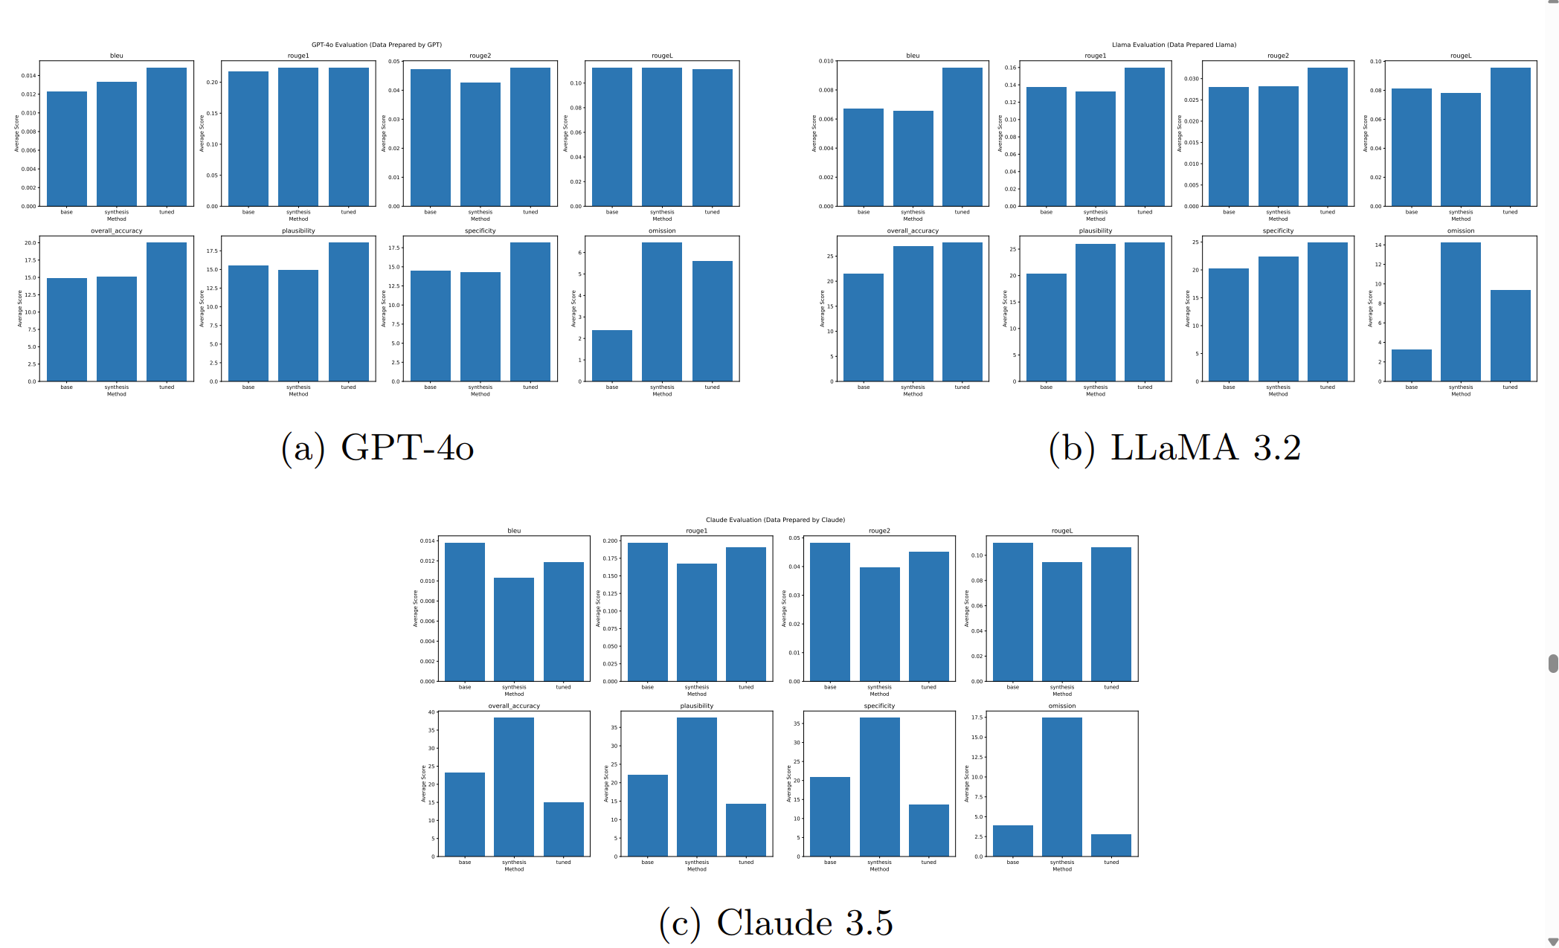
Figure 25:Metric-wise comparison across methods with LLM-prepared data.
LLM-extracted inputs introduce moderate noise, yet overall method rankings remain consistent across models. For Claude 3.5, the MediSyn variant yields the highest accuracy and specificity among the three configurations, demonstrating resilience to input imperfections and strong interprofessional structure. However, surface metrics (BLEU, ROUGE) remain highest in the base version, highlighting a tradeoff between lexical overlap and clinical structure. GPT-4o performs best under prompt tuning, showing peak values across accuracy, plausibility, and specificity, with relatively low omission. MediSyn remains competitive but does not surpass the tuned variant. For LLaMA 3.2, prompt tuning again leads in accuracy and plausibility, while MediSyn improves role segmentation and specificity, albeit with slightly elevated omission. These patterns affirm that prompt engineering remains effective under noisy conditions, while MediSyn enhances interprofessional fidelity and content depth across models.
These figures highlight that manual data consistently enhances absolute accuracy scores and reduces omissions across all models. Among the LLMs, Claude 3.5 benefits most from the MediSyn framework, especially under noisy input conditions—showing a pronounced increase in both accuracy and specificity. GPT-4o demonstrates its strongest performance with prompt-tuned inputs in both data regimes, while its MediSyn variant trails slightly, offering modest improvements in structural clarity but

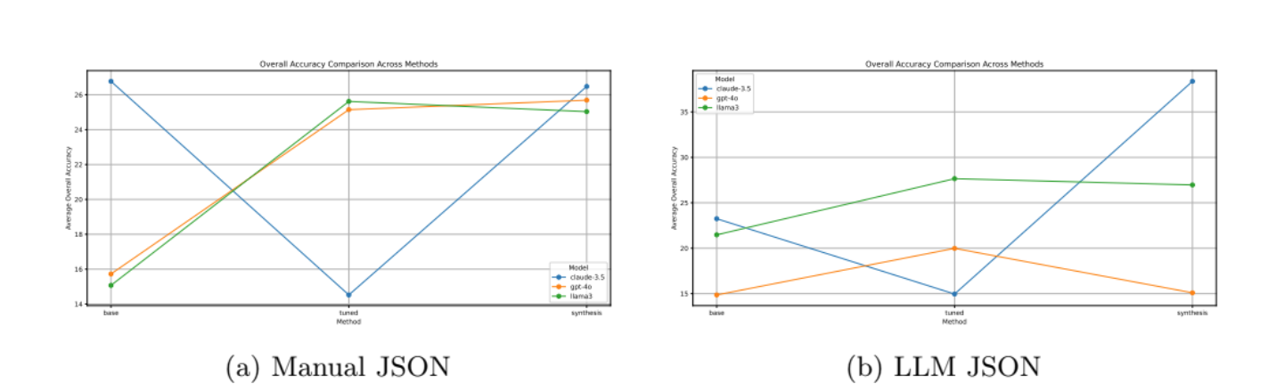
Figure 26:Average overall accuracy across models and methods.
lower overall accuracy. LLaMA 3.2 reaches peak accuracy with prompt tuning, though MediSyn improves specificity and maintains competitive results despite slightly elevated omission. Overall, MediSyn proves particularly effective for Claude and remains a resilient method under LLM-extracted data, reinforcing its utility in collaborative clinical reasoning contexts. For completeness, we include full metric tables below. These tables serve as a quantitative reference for the results summarized in the main text and figures.
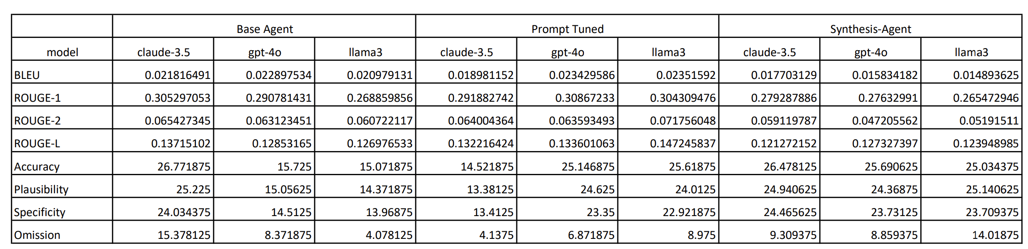
Figure 27: Evaluation Table: Manually Prepared Data
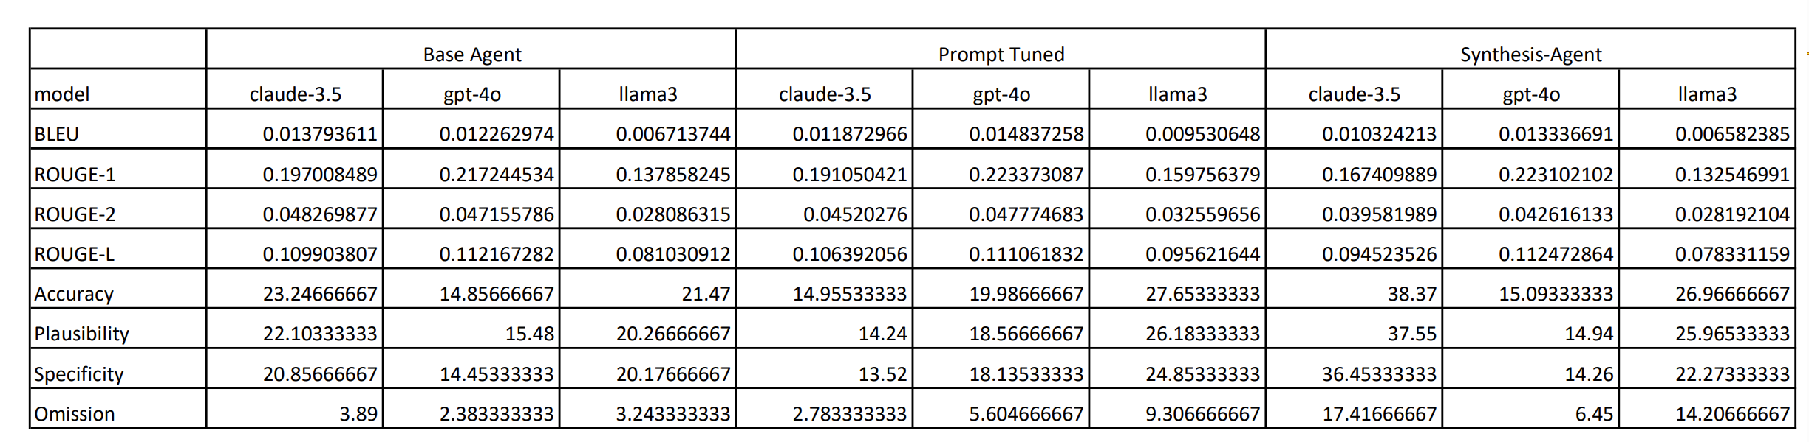
Figure 28: Evaluation Table: LLM Prepared Data
How does the quality of treatment plan generation differ when using manually prepared data versus LLM-prepared data?
Across all models and generation methods, manually curated input consistently led to higher accuracy, greater specificity, and fewer omissions. This is most pronounced for Claude 3.5, which saw substantial gains under the MediSyn framework when fed clean, manually structured JSON. LLaMA 3.2 also benefited from manual data, particularly in its prompt-tuned configuration, which achieved peak accuracy. GPT-4o showed smaller shifts across data regimes but remained most consistent with prompt tuning.
By contrast, LLM-prepared data introduced mild degradation in formatting content fidelity, likely due to field inconsistencies or paraphrasing during auto-extraction. However, MediSyn’s synthesis step mitigated much of this noise for Claude and LLaMA, maintaining strong performance even with imperfect inputs. Prompt tuning helped GPT-4o maintain high plausibility and structure despite reduced granularity.
Overall, while manual input remains the gold standard for structured fidelity, the results confirm that LLM-generated input can produce high-quality treatment planning when paired with prompt tuning or multi-agent synthesis architectures like MediSyn.

Discussion
This work presents MediSyn, a modular multi-agent generation system designed to emulate real-world interprofessional collaboration in clinical decision-making. Evaluated across 15 diverse IPE case studies, our findings show that MediSyn consistently enhances the structural fidelity, role attribution, and contextual depth of treatment plans when compared to single-LLM and prompt-tuned approaches. The architecture’s ability to simulate discipline-specific perspectives—while synthesizing them into 26 a unified treatment plan—proved especially effective for Claude 3.5 and LLaMA 3.2. Even GPT-4o, which tends to produce more compact outputs, demonstrated improved interprofessional coherence when integrated into the MediSyn framework.
A central theme in our analysis is the contrast between qualitative and quantitative evaluation outcomes. On the one hand, qualitative inspection—supported by examples in Section 4.3—clearly favored MediSyn for its role-sensitive structure, clarity, and alignment with IPE documentation practices. On the other hand, quantitative metrics such as BLEU and ROUGE did not always reflect these strengths, with prompt-tuned or even base configurations outperforming MediSyn on surface-level n-gram overlap. This divergence raises a critical question for the field: To what extent should we rely on traditional lexical metrics when evaluating clinical reasoning outputs, and when should human-aligned criteria—such as plausibility, specificity, and interprofessional clarity—take precedence? Addressing this requires deeper collaboration with domain experts to define evaluation benchmarks that align with both medical and educational standards.
Despite its promise, MediSyn has limitations. First, our use of GPT-4o as an LLMbased evaluator—while scalable and consistent—remains a proxy for expert human judgment. Although GPT-4o offers high fluency and general-purpose reasoning, its assessments may not fully capture clinical appropriateness or educational value. Future work should incorporate expert clinician evaluation for more robust validation. Second, while we employed 15 case studies covering a range of team compositions and conditions, this sample size remains modest for large-scale benchmarking.
Third, although MediSyn is designed to be model-agnostic, our analysis focused on three LLMs (GPT-4o, Claude 3.5, and LLaMA 3.2) without fine-tuning. Incorporating domain-adapted or instruction-tuned versions may reveal additional benefits or alter observed performance patterns.
Lastly, the modularity of MediSyn introduces its own challenges. Role prompts must be carefully crafted to ensure scope fidelity, and synthesis quality depends on the coherence of upstream agent outputs. Imperfections in auto-extracted input (e.g., ambiguous role mentions) can propagate into the final plan, especially under noisy LLM-prepared conditions.
Nonetheless, our results affirm that MediSyn provides a promising foundation for simulating collaborative clinical reasoning. Its ability to encode domain boundaries, promote inter-agent diversity, and synthesize profession-aware outputs makes it a valuable tool for both AI-driven medical education and the development of future interprofessional support systems.

Conclusion
We introduced MediSyn, a multi-agent generation framework that simulates interprofessional reasoning for medical treatment planning. By dynamically instantiating role-specific agents and synthesizing their outputs, MediSyn produces structured, collaborative plans aligned with IPE/IPP practices. Evaluated on 15 diverse case studies, MediSyn demonstrated strong performance in producing clinically coherent and role-attributed outputs, particularly when paired with models like Claude 3.5 27 and LLaMA 3.2. While prompt tuning improved alignment in many cases, MediSyn consistently enhanced structure and interprofessional clarity—especially under noisy, LLM-prepared inputs.
Our findings underscore the limitations of surface-level metrics and highlight the value of human-aligned evaluation criteria such as specificity and plausibility. As LLMs continue to evolve, frameworks like MediSyn offer a promising foundation for AIassisted education and team-based clinical reasoning, with opportunities for further refinement through expert evaluation and domain-specific tuning.

References

[1] World Health Organization. Framework for Action on Interprofessional Education and Collaborative Practice. Geneva: WHO (2010). https://www.ncbi.nlm.nih.gov/books/NBK207102/
[2] Han, S., Choi, W. Development of a large language model-based multi-agent clinical decision support system for Korean triage and acuity scale (KTAS)-based triage and treatment planning in emergency departments. arXiv preprint arXiv:2408.07531 (2024).
[3] Wilk, S., Kezadri-Hamiaz, M., Rosu, D., et al. Using semantic components to represent dynamics of an interdisciplinary healthcare team in a multi-agent decision support system. Journal of Medical Systems, 40(2), 42 (2016). https://doi.org/10.1007/s10916-015-0375-3
[4] Mohammadzadeh, N., Safdari, R., Rahimi, A. Multi-agent systems: effective approach for cancer care information management. Asian Pacific Journal of Cancer Prevention: APJCP, 14(12), 7757–7759 (2013). https://doi.org/10.7314/apjcp.2013.14.12.7757
[5] Singhal, K., Azizi, S., Tu, T.-J., et al. Large language models encode clinical knowledge. arXiv preprint arXiv:2302.12347 (2023).
[6] Biswas, S., et al. Role of ChatGPT in healthcare: a scoping review. Cureus, 15(3), 35984 (2023).
[7] Patel, S., Lam, K., et al. ChatGPT in medical literature: A concise review and SWOT analysis. Cureus, 15(4), 37686 (2023).
[8] Nori, H., King, N., et al. Capabilities of GPT-4 on medical challenge problems. arXiv preprint arXiv:2303.13375 (2023).
[9] Lee, S., Park, D. Benefits and limitations of GPT-4 in clinical documentation. NPJ Digital Medicine, 6(1), 89 (2023).
[10] Li, H., et al. Can ChatGPT pass medical licensing exams? PLOS Digital Health, 2(1), 0000283 (2023).
[11] Rai, V., et al. Prompt engineering for clinical reasoning: Limitations and opportunities. Journal of Biomedical Informatics (2023). In press.
[12] Ghazal, B., et al. A multiagent system for patient monitoring and decision support in critical care environment. Future Generation Computer Systems, 34, 124–137 (2014).
[13] Lemke, C., Gaber, M., et al. Agent-based decision support for emergency medical services. Journal of Ambient Intelligence and Humanized Computing, 2, 219–230 (2011).
[14] Abidi, S., et al. An ontology-based multi-agent system for patient monitoring in cardiac intensive care. Artificial Intelligence in Medicine, 78, 52–61 (2017).
[15] Wang, Y., Li, Z., et al. ClinicalAgent: LLM-as-agent for clinical trial task automation. arXiv preprint arXiv:2401.11054 (2024).
[16] Zhang, W., Liu, M., Chen, L., et al. KG4Diagnosis: A hierarchical multi-agent LLM framework with knowledge graph integration for medical diagnosis. arXiv preprint arXiv:2412.16833 (2024).
[17] Wei, J., Yang, D., Li, Y., et al. MedAide: Towards an omni medical aide via specialized LLM-based multi-agent collaboration. arXiv preprint arXiv:2410.12532 (2024).
[18] Kim, Y., Park, C., Jeong, H., et al. MDAgents: An adaptive collaboration of LLMs for medical decision making. In: NeurIPS 2024 (2024).
[19] Liu, X., Wang, H., Zhang, R., et al. Enhancing diagnostic capability with multi-agent conversational frameworks. NPJ Digital Medicine, 8(1), 45 (2025).
[20] American Speech-Language-Hearing Association. All Health Care Case Studies - IPE/IPP. Accessed: 2025-04-15 (2024). https://www.asha.org/practice/ipe-ipp/case-studies/health-care/
[21] Croxford, E., Gao, Y., Patterson, B., To, D., Tesch, S., Dligach, D., Mayampurath, A., Churpek, M.M., Afshar, M. Development of a human evaluation framework and correlation with automated metrics for natural language generation of medical diagnoses. medRxiv (2024). https://doi.org/10.1101/2024.03.20.24304620 (Preprint).
[22] Liu, P., Yuan, W., et al. Pre-train prompt fine-tune: A survey on prompt engineering for large language models. arXiv preprint arXiv:2107.13586 (2023).
[23] Author, A. Prompt engineering in healthcare. Journal of Medical AI, 10(2), 100–110 (2024).
[24] Author, B. Prompt engineering for patient education using large language models. Health Informatics Journal, 12(1), 50–60 (2025).
[25] Author, C. Enhancing clinical decision support through prompt engineering. AI in Medicine, 15(4), 200–210 (2023).

